HY-TB4DV-HH（HL） 4-axis drive board manual
Thank you for choosing our company's products, the use of CNC products better and faster for you, please read this manual
Features: Features
1: Pulse can be equipped with an external handle with digital display, with the handle can automatically switch the computer and handle control, mutual non-interference, and automatically shielded handle control functions automatically detect the computer-controlled movement, a few significant track record computer data and handle control of mobile data
2：Computer path track record of running in the computer processing time can be record keeping, processing data offline automatically repeat the processing run.
3：Manually move the processing and record keeping, traceability records manually move the machine data, and automatically repeat the processing run manually move the path.
4：Manual data input processing path, and automatically run the input path
5: The driver XYZ-axis or Z axis of the knife can be done automatically, without the operation of complex computer software
6: Up to 3.5A stepper motor drive current, adjustable.
7: Up to 16 segments, higher accuracy, and run more smoothly.
8：Overload flow through the temperature automatic protection function, and fully protect your computer and peripherals
9: Bipolar constant-current chopper drive, low speed creeping phenomenon, noise, non-resonant region.
10: Closed optical isolation, two-stage signal processing, to fully protect your computer and equipment.
11：A the road 0-10V/PWM speed control signal output
12: Rd input control, you can set the limit, stop, which is divided into the knife.
Electrical properties (ambient temperature Tj = 25 ℃):
Input power | 12 - 36V DC power supply
Output current | 3A (peak 3.5A)
Driven approach | Bipolar constant-current PWM drive output.
The drive motor | 42,57,86 stepper motors, two phase -4 phase (4-wire, 6 wire and 8 wire stepper motor)
Weight | About 300g。
Segments set the table：
Current | SW6 | DW5 | Buffer | SW4 | SW3 | Sub | SW2 | SW1
100% | ON | ON | 25% | ON | ON | 1 | ON | ON
75% | ON | OFF | 50% | ON | OFF | 2 | ON | OFF
50% | OFF | ON | 75% | OFF | ON | 8 | OFF | OFF
25% | OFF | OFF | 100% | OFF | OFF | 16 | OFF | ON

Signal waveform and timing
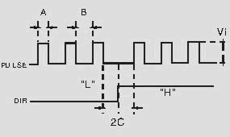
Power output interface functions
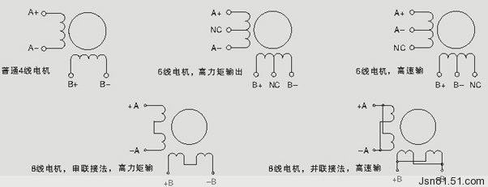
Interface marked detail map
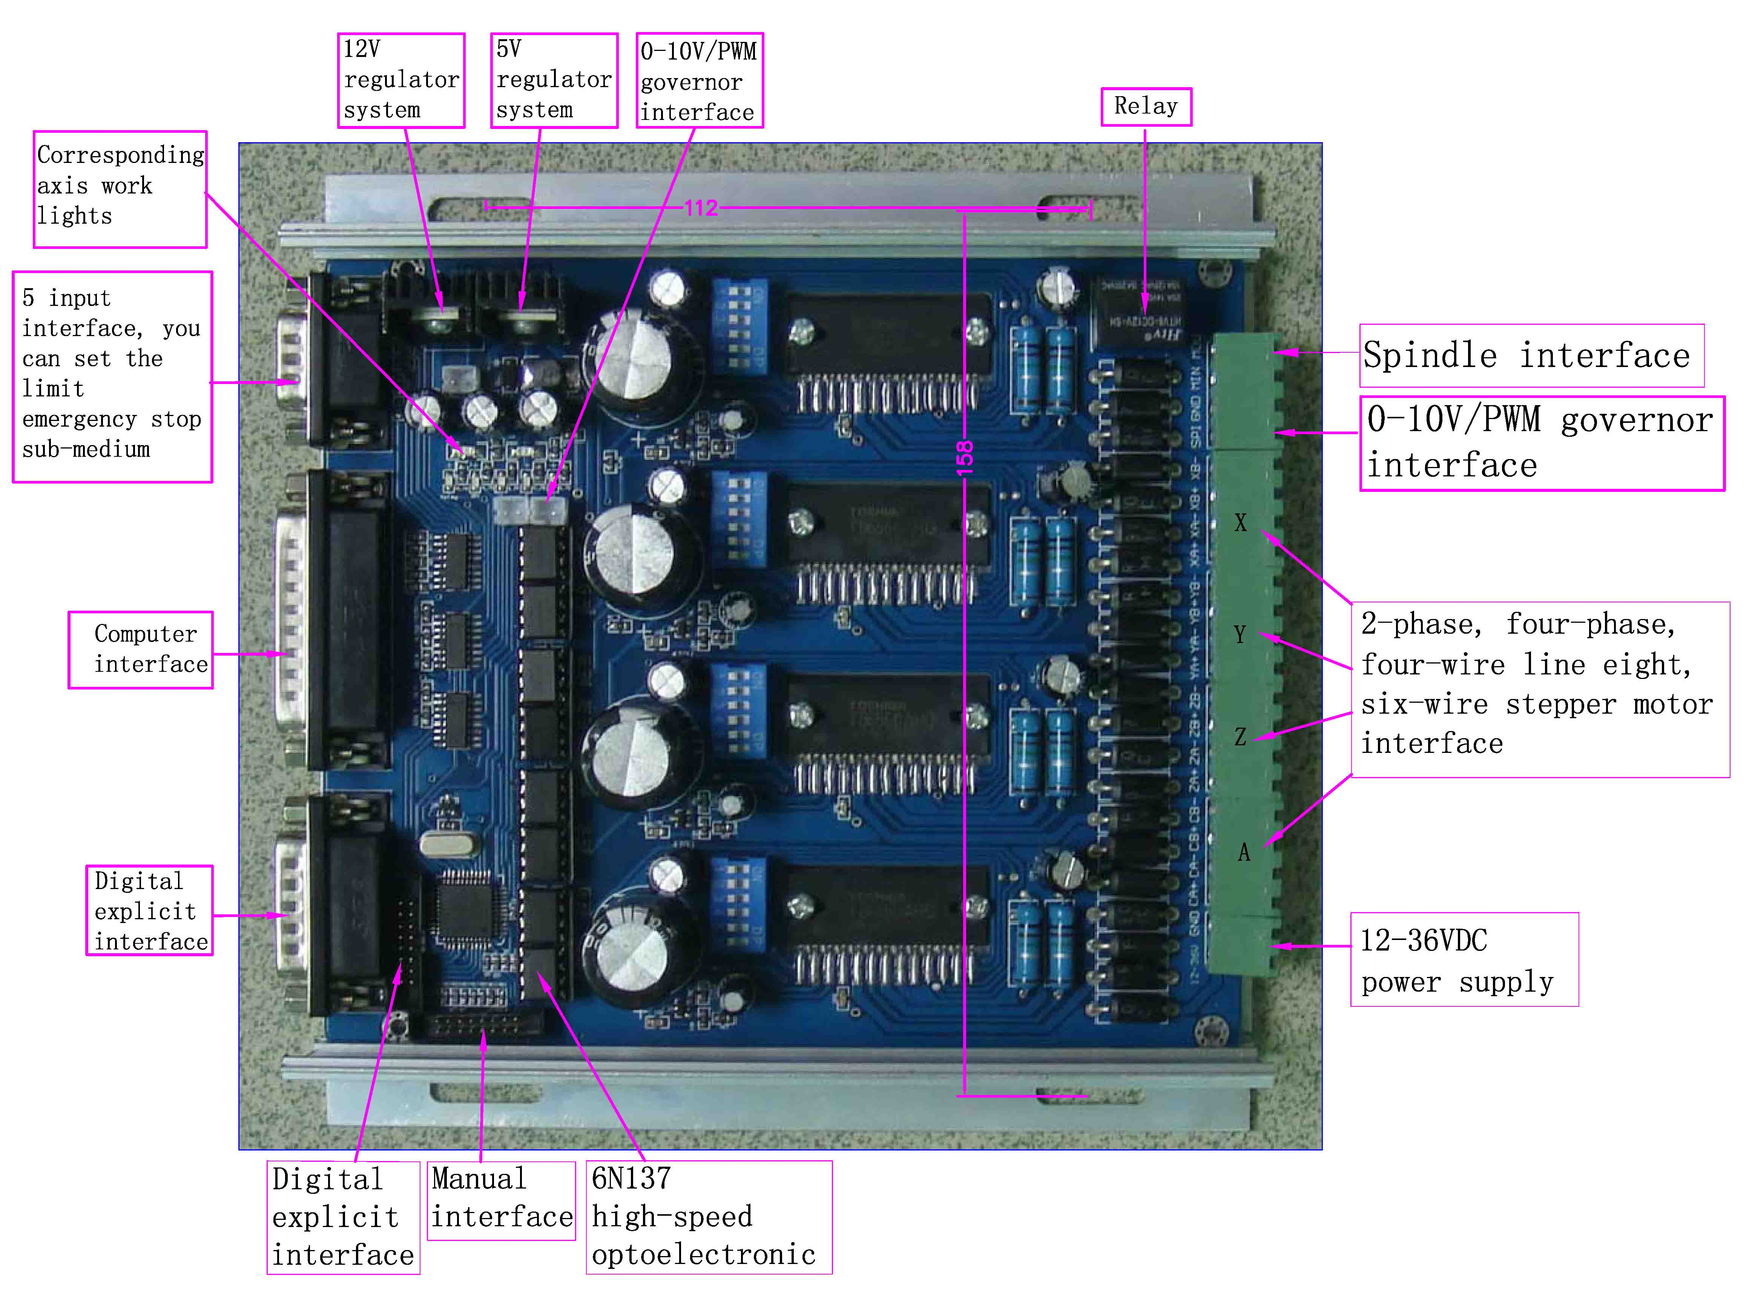
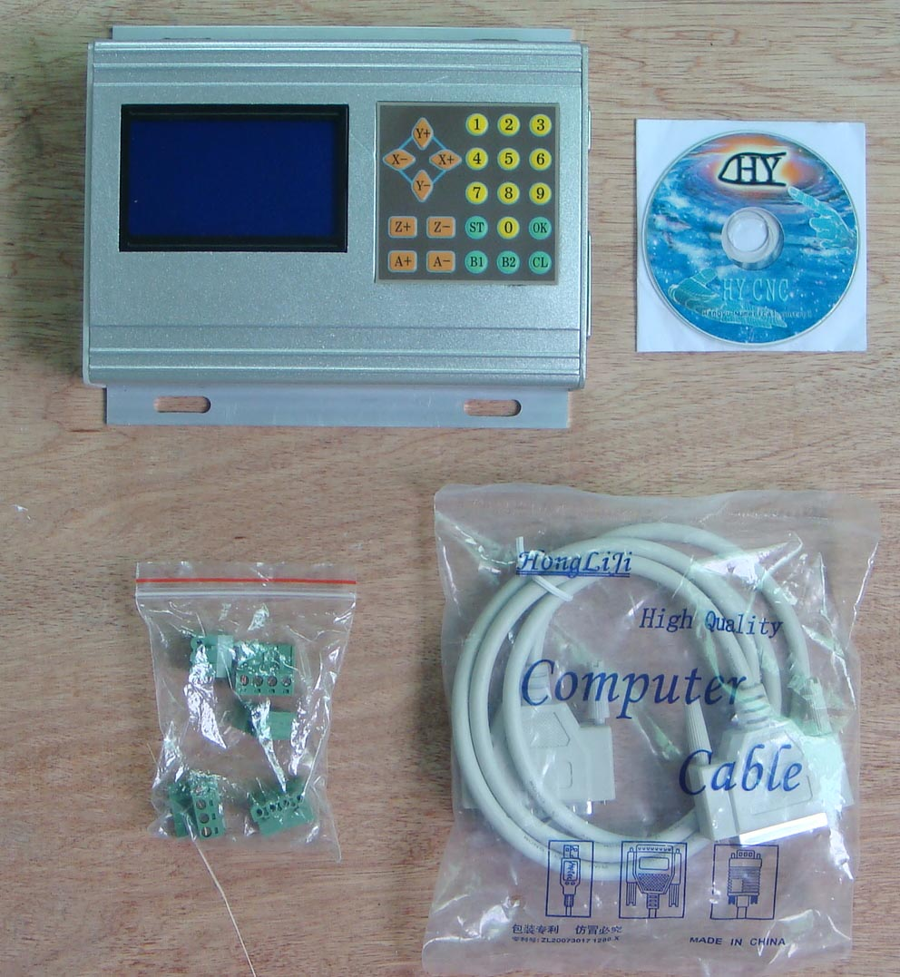
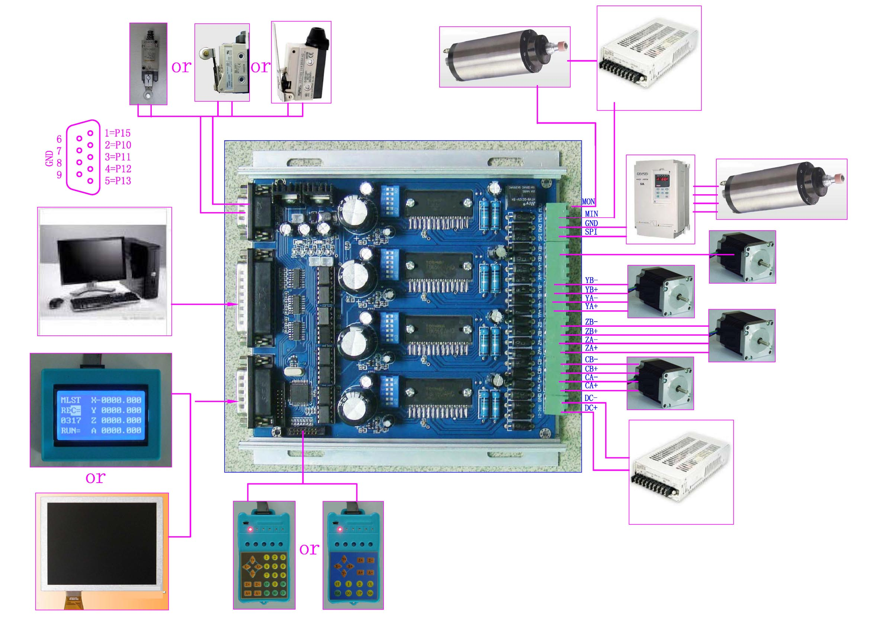
Operating Instructions：
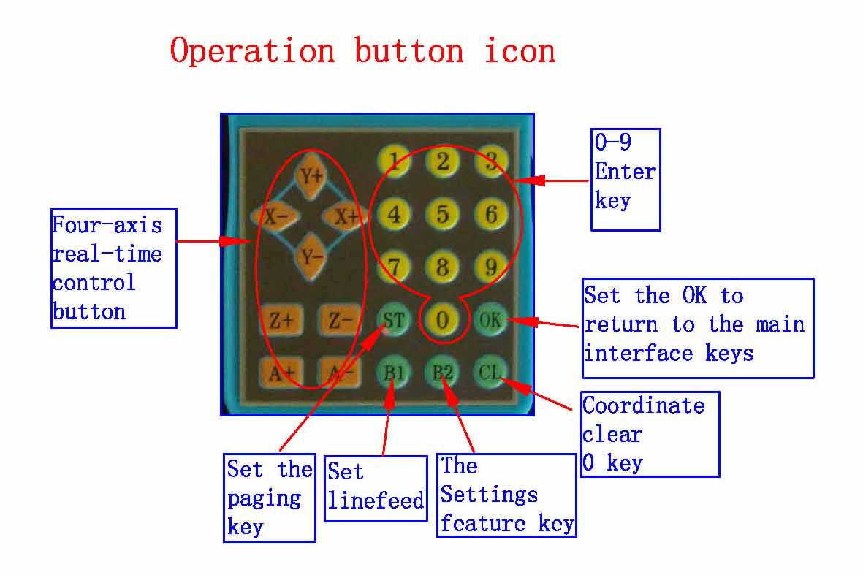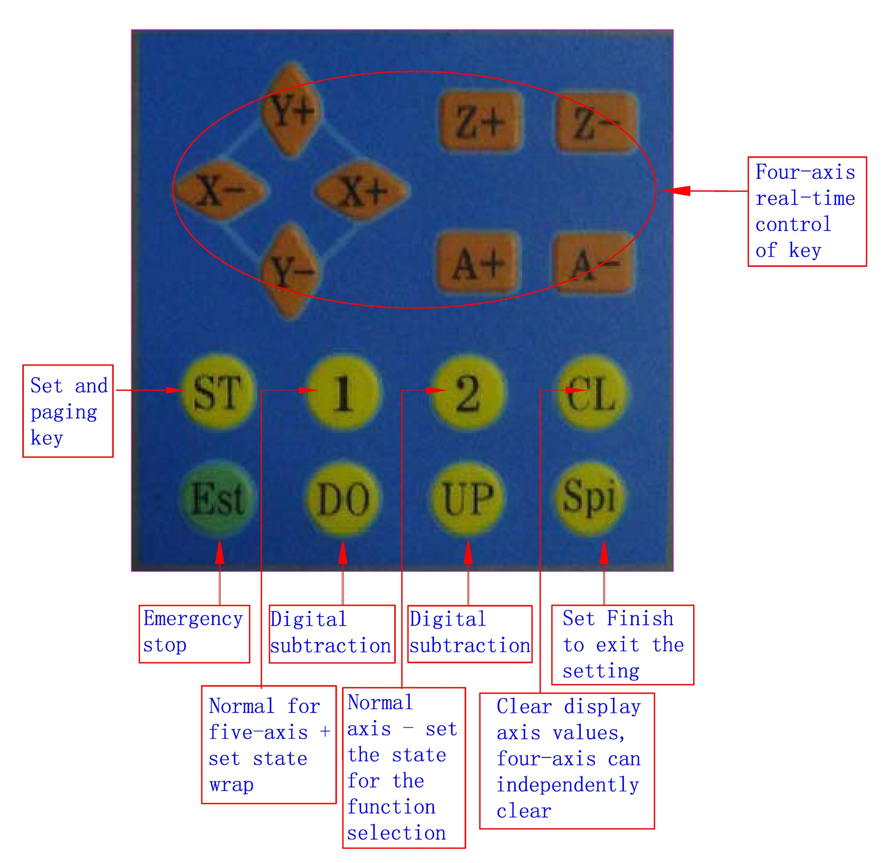
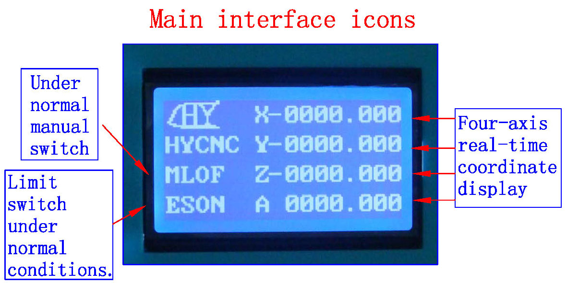
1: The coordinates of display range 9999.999/-9999.999
2: automatically records the computer running coordinates and manually move the coordinates
3: Automatic switch between computer and manual control
4: computer-controlled automatically shielded manual control functions, two seconds after the return to manual function
1：ST button press the handle into the lower settings menu, set the complete press the OK button to return to the main interface
2：Replaced by B1 line, according to the four-axis handle CL button corresponding axis to 0, press the OK button to exit0
3：Four-axis real-time recording computer running coordinates and manually move the coordinates, the value of the computer running data + manually move the data
===================================================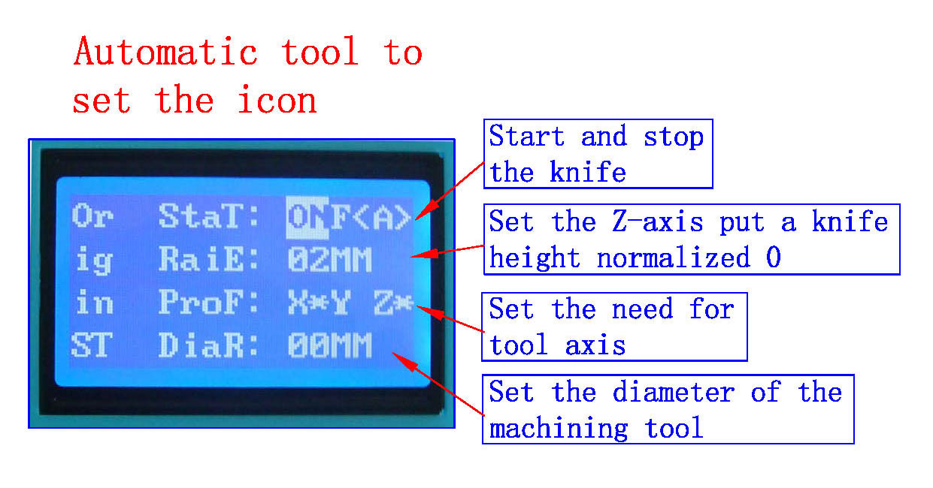
1: all settings automatic permanent preservation until the next set of updates
2: You can set the radius, put a knife height parameters
3: The driver auto-complete the knife, without the complexity of computer software operation, convenient tool change school knife, boot knife, batch processing adequately protected on the knife and other processed products correctly
1：In order to ensure the accuracy of the knife, the knife before check put a knife height parameters and tool diameter is set correctly，
2：Need to confirm that the knife instrument wiring and limit switch wiring status is normal。
3：B2 keys and press to confirm OK to enter the automatic tool operation and automatically stop after the completion of。
4: Press the keyboard (A-) exit status of the school knife
====================================================
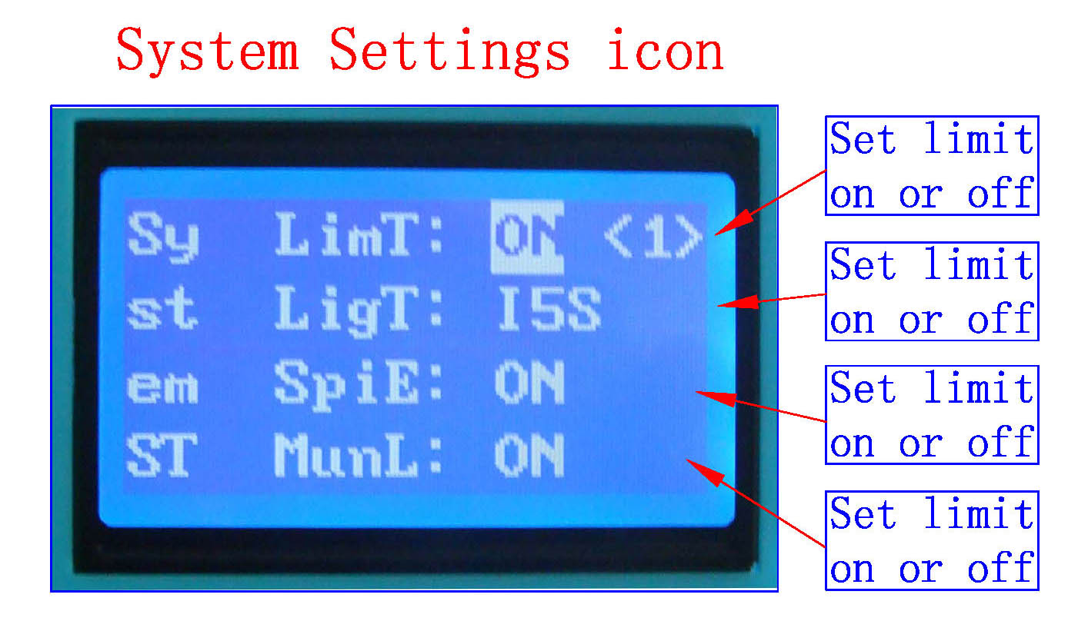
; All settings automatically saved permanently, until the next set update
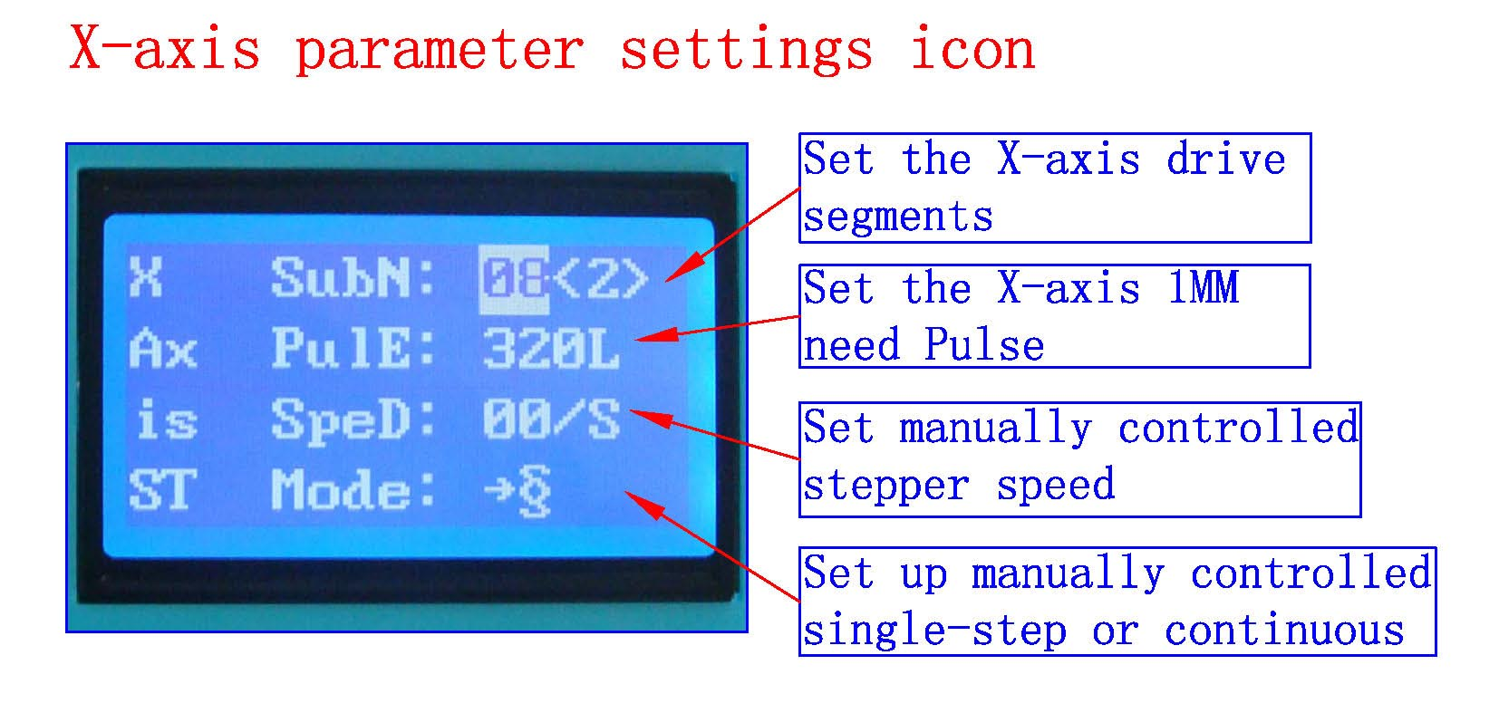
; All settings automatically saved permanently, until the next set update
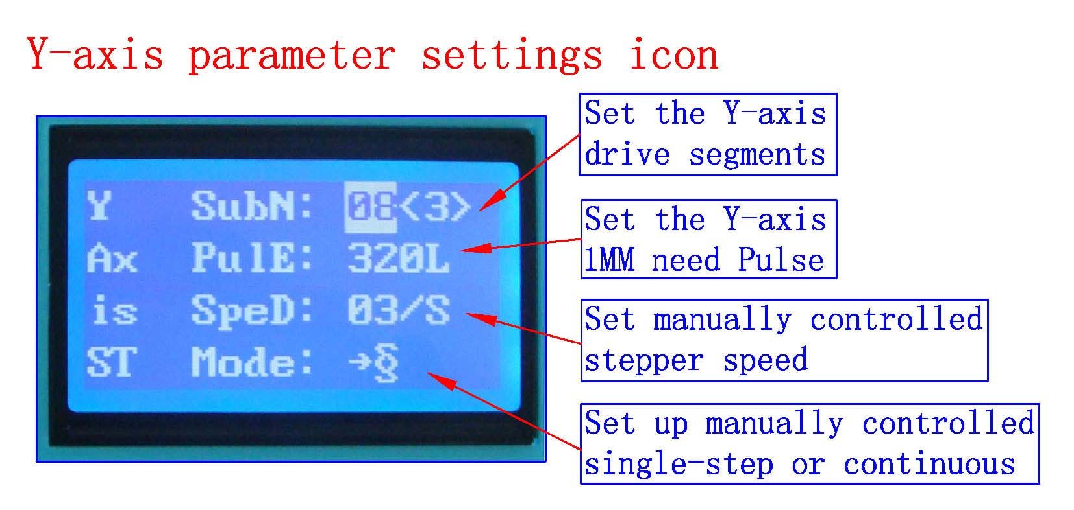;
; All settings automatically saved permanently, until the next set update

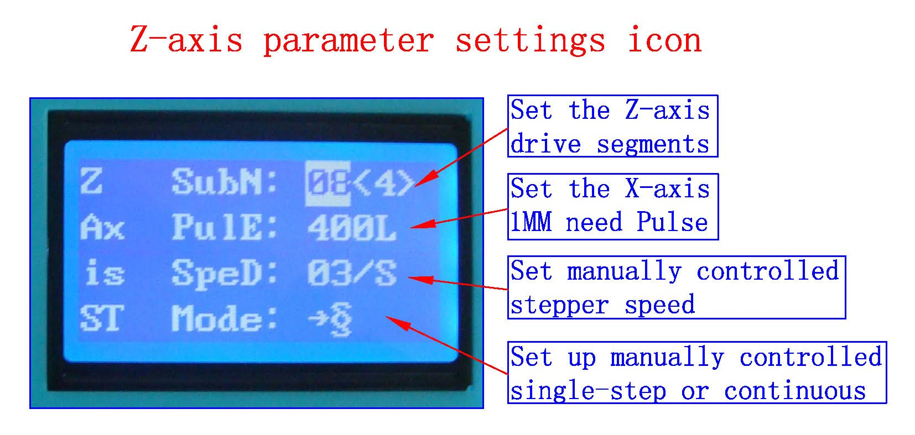
; All settings automatically saved permanently, until the next set update
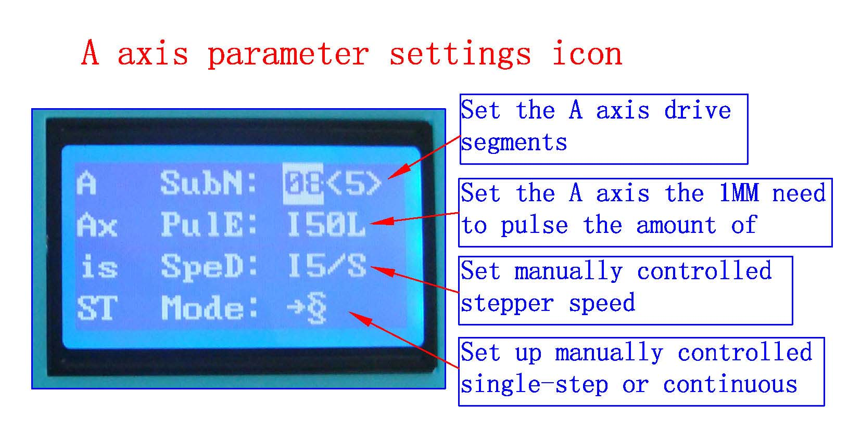
; All settings automatically saved permanently, until the next set update
1：ST button of the handle into the lower-level settings menu, the setup is complete press the OK button to return to the main interface
2：Downstream set shift handle B1 button，
3：Handle B2 button corresponding anti-white set at function selection
4：Handle the number keys, enter the set numeric argument
The following three functions for the professional version of the product features
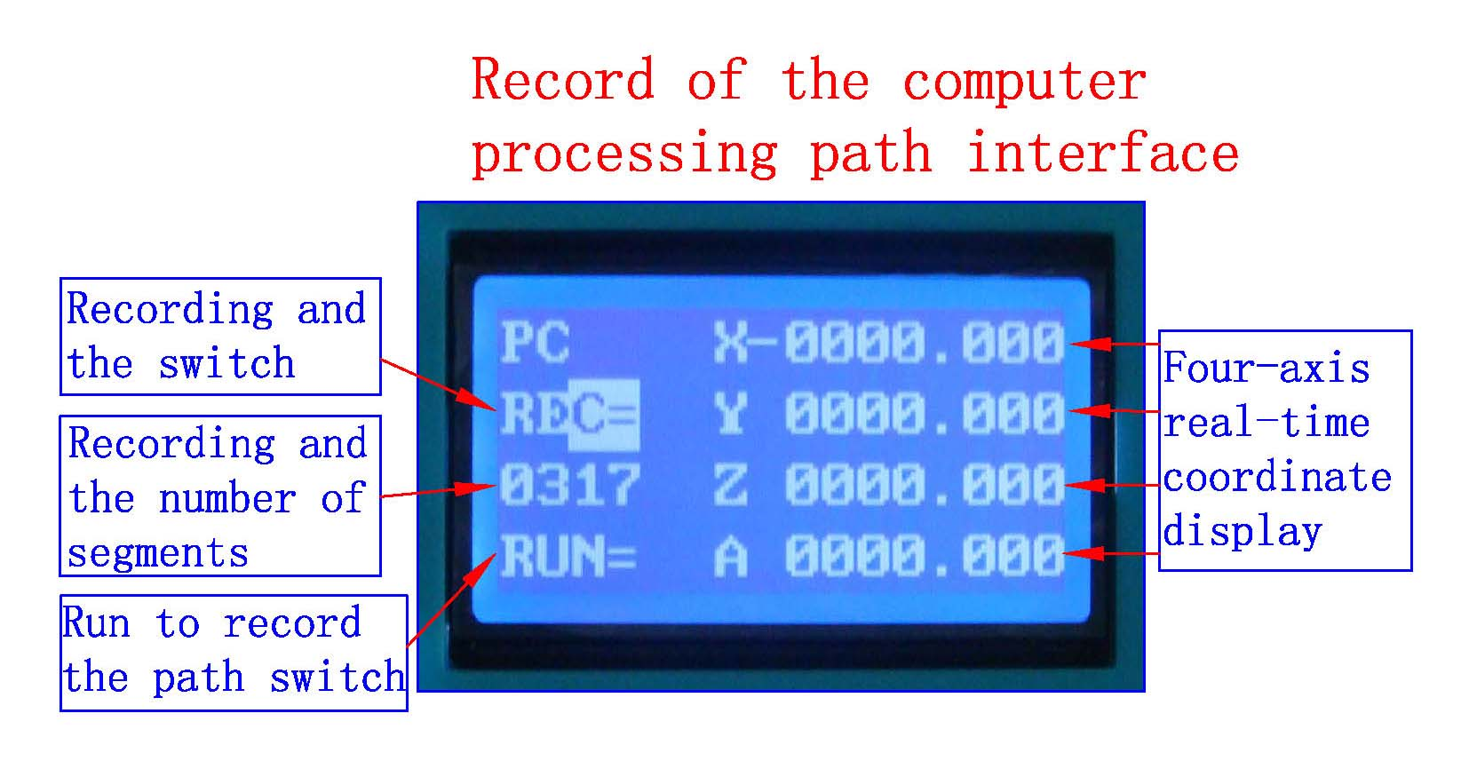
1: The coordinates of display range 0-9999.999
2: automatically records the computer running data automatically permanent preservation, to to be updated before the next recording
3: recorded 1800 segment
4: (To increase the volume can be customized plug-U disk recording the number of segments, unlimited recording)
1: Display REC state B2 key to start the computer running data record will show a record number of segments, the biggest record of 1800 segments, and then B2 button to stop.
2：Wrap press B1 keys to display the status RUN, then B2 key to start the operating records to save the computer operating data, and then B2 button to stop
3：Press ST button to enter the lower-level menu settinigs
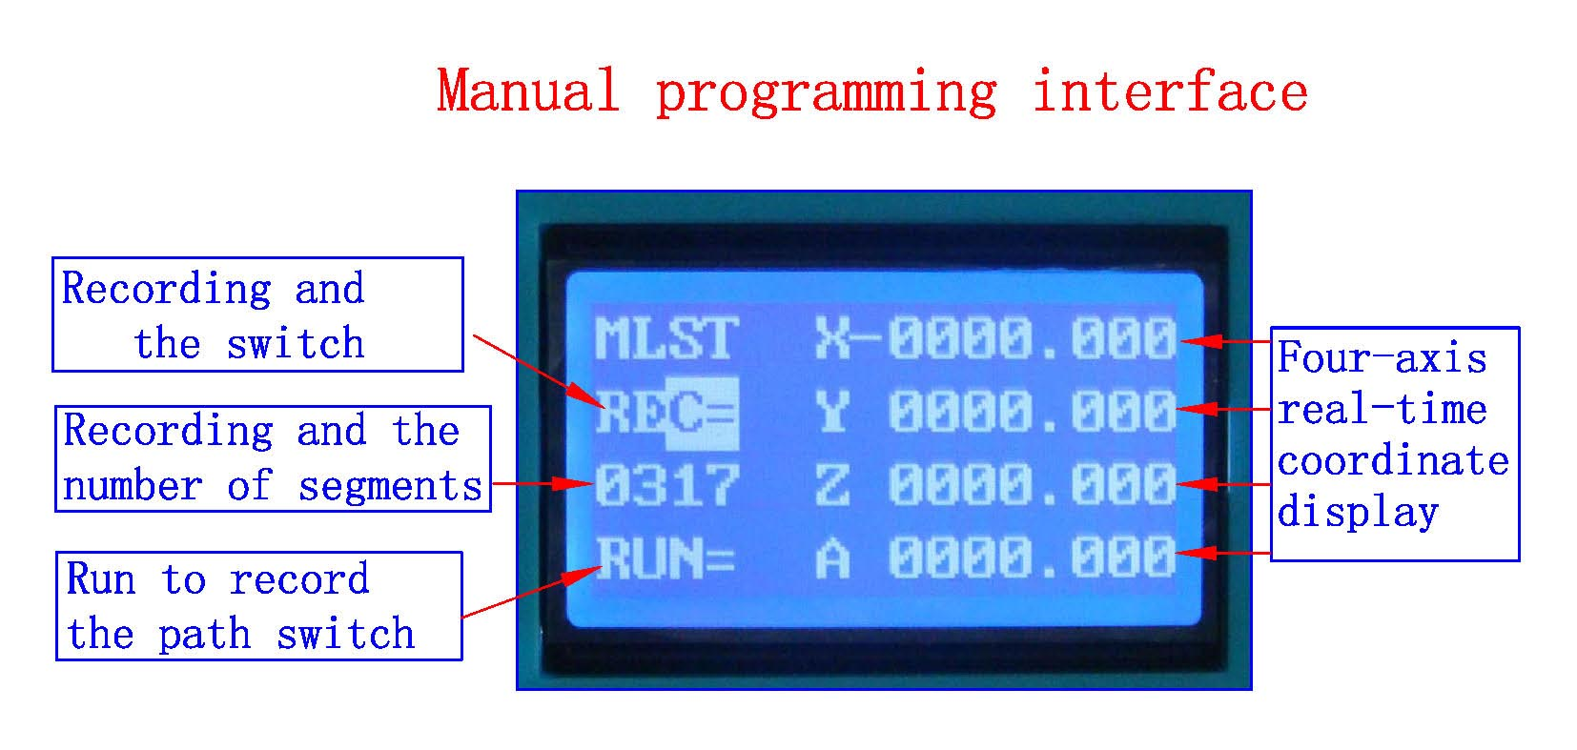
1: The coordinates of display range 0-9999.999
2: supports both digital input manually coordinate programming and manual actually moving coordinate programming
3: recorded 1800 segment
4: (To increase the volume can be customized plug-U disk recording the number of segments, unlimited recording)
1：B2 enter the run and stop switch, switch B1 wrap
2：REC recording, press the four-axis real-time control keys to move the machine coordinates (each can only change a-axis data and then B2 key to save) save the coordinates of the real-time axis, according to the B2 key, press the CL key to manually enter the appropriate axis numeric keypad to enterthen B2 key to save the real-time axis coordinate (you can only change the axis of data B2 button to save), the recording OK and press B1 button to switch to the display RUN，
3：Press the OK button to exit back to the main interface
============================================
Please note the following before the test machine
- Test machine first to 12V voltage test machine, 42-step, please with 12-16V/DC power, 57 stepper Please choose 16-24V/DC power, 86 stepper election 24-36V/DC power
- The stepper motor power and current (model)
- Determine the wiring of the stepper motor
二》Each pin definitions
1》Parallel port control is defined as follows:
PIN14 | PIN1 | PIN2 | PIN3 | PIN1 | PIN4 | PIN5 | PIN1 | PIN6 | PIN7 | PIN1 | PIN8 | PIN9 | PIN16
Relay | X  Allow | X  Direction | X  Pulse | Y  Allow | Y  Direction | Y  Pulse | Z  Allow | Z  Direction | Z  Pulse | A  Allow | A  Direction | A  Pulse | 0-10VPWM

3》Limit 1 ~ PIN9 defined as follows (figures defined inside the interface marked)
X-axis limit | Y-axis limit | Emergency stop | Z-axis limit | Alternative input | DC-
InterfaceP1 | InterfaceP2 | InterfaceP3 | InterfaceP4 | InterfaceP5 | InterfaceP6-P9
Thecorresponding computerP12 | Corresponding computerP13 | Corresponding computerP15 | Corresponding computerP11 | Corresponding computerP10 | GND

4》Output interface is defined (in the picture for 1 to 22)
P1 | P2 | P3 | P4 | P5 | P6 | P7 | P8 | P9 | P10 | P11 | P12 | P13 | P14 | P15 | P16 | P17 | P18 | P19 | P20 | P21 | P22
Positive | Ground | AA+ | AA- | AB+ | AB- | ZA+ | ZA- | ZB+ | ZB- | YA+ | YA- | YB+ | YB- | XA+ | XA- | XB+ | XB- | GND | 0-10 | MOA | MOB

Power is connected to 12 36V 8A (Optional according to the stepper motor operating current) above switching power supply, received marked on the power input interface。
12V power output is used to pick up the 12V cooling fan。
The spindle motor control is controlled through the parallel port PIN14. The spindle motor voltage must comply with the supply voltage range。
三》MACH software using the method
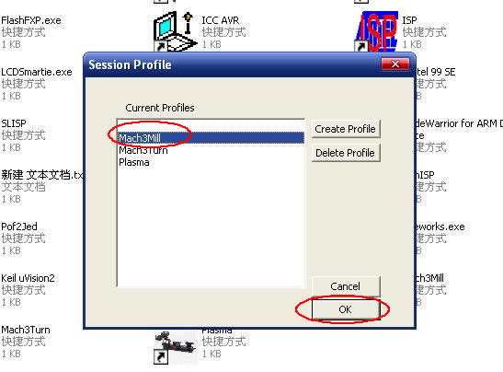
Figure1
Figure 1, open the MACH3 software, now mach3MILL then select OK
Figure2

MACH3 open the interface shown in Figure 2, above the action button, where we first configure the MACH software。
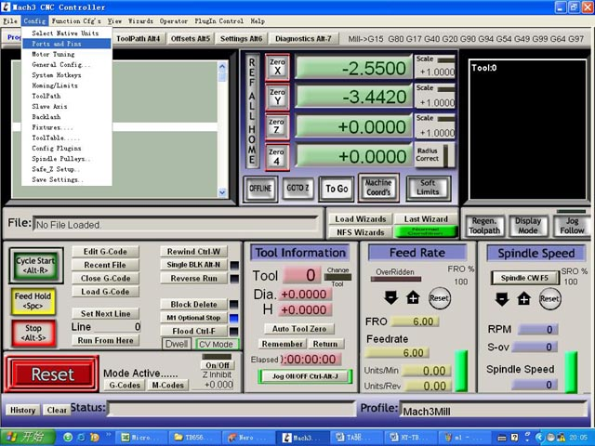
Figure 3
Figure 3, open the config menu PORT PIN menu
Figure 4
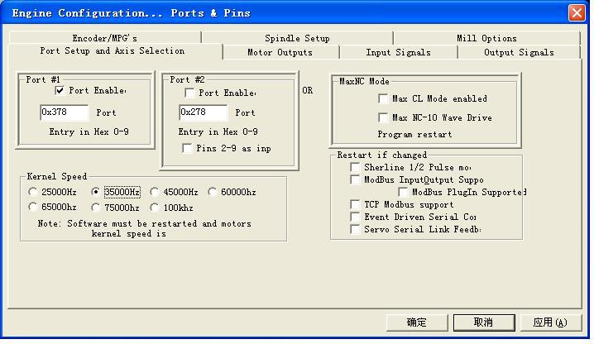
Figure 4

Set on the circle a place where you can set the fundamental frequency, this parameter of the motor rotation speed. Set up, select the circle place, the configuration of the definition of the foot, as shown in Figure5 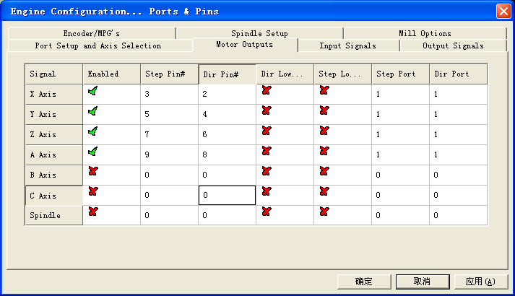

Figure 5

According to the definition of the parallel port of the board, follow the map circle to indicate the definition modify the software settings。
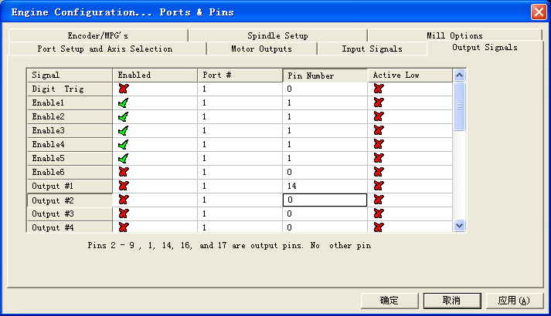

Figure 6
Then part in the selection output signals, as shown in Figure 6, according to the settings of the circle, set the appropriate。

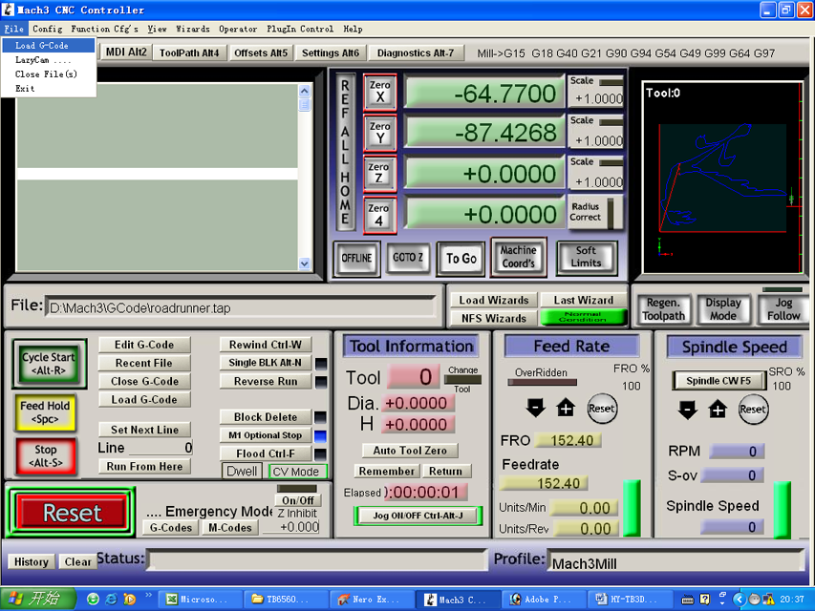
Figure 7
All set ok, you can open the G code need to run, as shown in Figure7

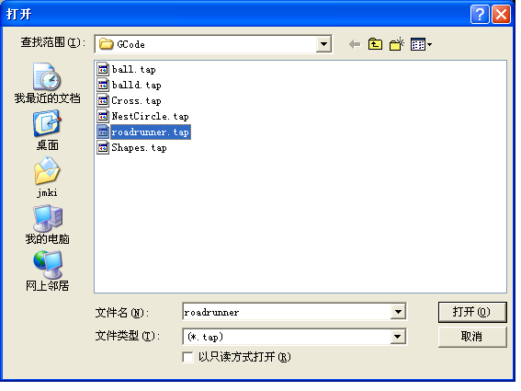
Figure 8

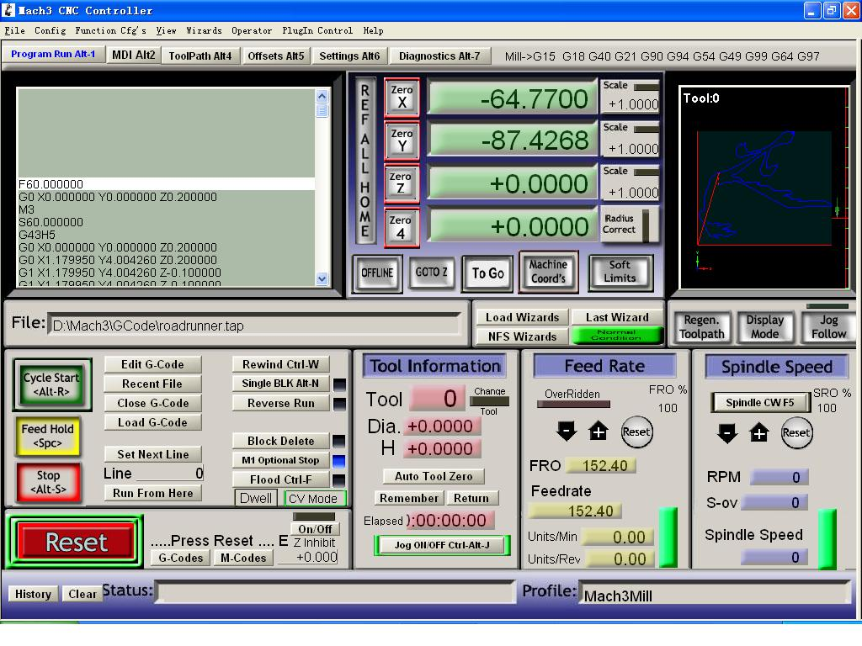
Figure 9
Open the G code, you can see the red the RESET flashing, you can use the mouse to click this RESET to stop flashing, then you can press circle the location CYCLESTART run.

